*Name: Trung Kien Nguyen*

*Student ID: 104053642*



COS20007

Object-Oriented Programming

REPORT

Key Object Oriented Concepts



***TABLE OF CONTENTS***

*Table of contents…………………………………………………………………………………………………….……….…2*

*Definition and the main concept..…………………………………………………………………………………….…3*

*Key principles……………………………………………………………………………………………………………………..4*

*Other concepts……………………………………………………………………………………………………………………6*

*Some terminologies…………………………………………………………………………………………………………….7*

*References………………………………………………………………………………………………………………………….8*

**DEFINITION AND MAIN CONCEPT**

Object-oriented programming (OOP) is a programming paradigm that is based on the concept of "objects", and puts a great deal of emphasis on the objects than the logic and function that go into the creation of software. An object is a self-contained entity that contains both data (attributes or properties) and behavior (methods or functions) that operate on that data.

In OOP, programs are organized around objects and their interactions with each other. The main idea is to encapsulate data and behavior together into a single unit, which allows for better abstraction, modularization, and reuse of code. And, as programmers may alter and arrange items inside programmed, OOP is appropriate for complex, often updated, and large-scale applications. The diagram below describes the main ideas of OOP:

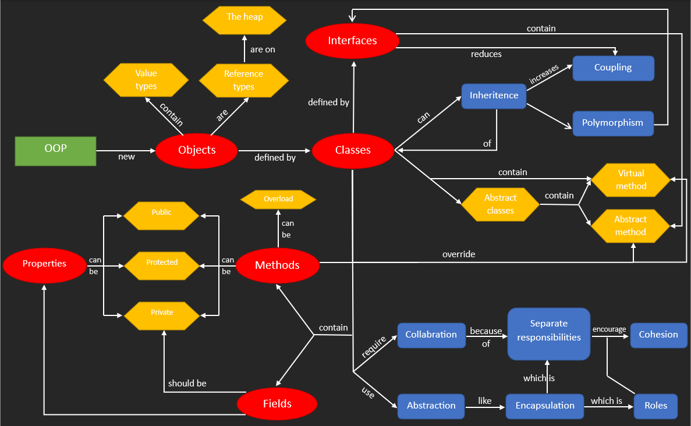

Overall, OOP provides a way to organize and structure code in a way that is more modular, maintainable, and scalable. It is widely used in modern programming languages, such as Java, C++, Python, and Ruby, and is considered to be a powerful and flexible way to structure programs.

**KEY PRINCIPLES**

There are four key principles of Object-oriented Programming (OOP), including ***Abstraction***, ***Encapsulation***, ***Inheritance***, and ***Polymorphism***.

1. **Abstraction:** Abstraction involves reducing complex systems or processes to simpler, more manageable components. In OOP, abstraction is used to create classes that represent real-world objects or concepts, while hiding unnecessary details. Abstraction allows us to focus on the essential characteristics of a system or object, while ignoring irrelevant or distracting details. Abstraction is closely related to encapsulation, as both principles involve hiding implementation details from external users or clients.
2. **Encapsulation:** This principle refers to the bundling of data and code within a single unit, or object. Encapsulation allows the object to control its own data, and to expose only the methods necessary for interacting with that data. This helps to ensure that the object's internal state remains consistent and protected from external interference.
3. **Inheritance:** This principle allows one class to inherit properties and methods from another class. Inheritance promotes code reuse and can help to simplify the design and implementation of complex systems. Inheritance relationships are typically represented as "is-a" relationships, where a subclass is a more specialized type of the superclass.
4. **Polymorphism:** Polymorphism refers to the ability of objects to take on different forms or behaviors, depending on the context in which they are used. Polymorphism allows different objects to respond to the same message or method call in different ways, based on their class or type. In other words, this means that the child class has both its type and its parent’s type. Thus, polymorphism promotes flexibility and extensibility in object-oriented designs.

Let take an example of the code I have done in the task *4.1P - Drawing Program - Multiple Shape Kinds*

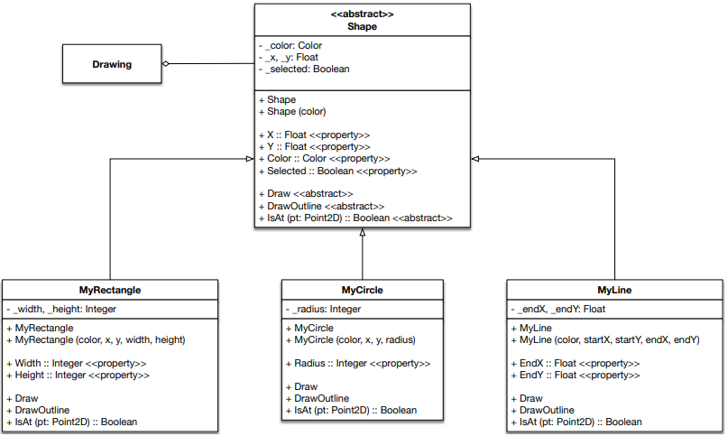

* Abstraction: The “Shape” abstract class provides an abstraction of a generic shape, which allows specific shapes, including “MyRectangle”, “MyCircle” and “MyLine”, to inherit from it and implement their own specific versions of its abstract methods. “MyRectangle”, for example, also provides an abstraction of a rectangle, encapsulating the properties and methods necessary to define a rectangle, while hiding its internal implementation details.
* Encapsulation: The "Shape" class encapsulates the data of a rectangle, including its "Color", "X", "Y", and "Selected" properties, and its methods "Draw", "IsAt", and "DrawOutline". The properties also include getter and setter methods for encapsulated access to their values.
* Inheritance: The "MyRectangle", "MyCircle", and "MyLine" classes inherit from the "Shape" abstract class, which is an example of inheritance in action. By inheriting from "Shape", those subclasses inherit its properties ("Color", "X", "Y", and "Selected"), and abstract methods ("Draw", "IsAt", and "DrawOutline"), which "MyRectangle", "MyCircle", and "MyLine" override with its own implementations specific to rectangles, circles, and lines respectively.
* Polymorphism: The "MyRectangle", "MyCircle", and "MyLine" classes demonstrate polymorphism by overriding the "Draw", "IsAt", and "DrawOutline" methods inherited from "Shape". This means that any code that expects a "Shape" object can also use a "MyRectangle", "MyCircle", or "MyLine" object in its place, since those are the types of Shape. For example, if there is a method that takes a "Shape" object as a parameter, it can be passed a "MyRectangle" object instead as "MyRectangle" is a subclass of "Shape".

**OTHER CONCEPTS**

In Object-Oriented Programming, there are some other important concepts, including:

* Collaboration:
  + In OOP, classes are designed to interact and collaborate with each other to achieve a larger goal or task. This collaboration is necessary because no class can fully accomplish a complex task on its own. Instead, different classes with unique functionalities and responsibilities work together to achieve a larger goal.
  + Collaboration in OOP can take different forms, such as method calls, message passing, and data sharing between objects. For example, one class may need to call a method or access a property of another class to complete a specific task. This is done by creating objects of the classes and then using them to exchange messages or call methods to communicate with each other.
* Responsibilities:
  + The concept of “responsibilities” in OOP refers to the tasks or functionalities that a class is responsible for. Each class in an application is designed to have specific responsibilities or areas of expertise, which help to organize and modularize the codebase, making it easier to maintain and extend.
  + A class's responsibilities can be defined by the methods and properties it contains, and the interactions it has with other classes. A well-designed class should have a clear and concise purpose, with its responsibilities being easy to understand and implement.
* Roles:
  + In OOP, "roles" refers to the different types of objects that can be created from a single class. A class can define multiple roles by exposing different interfaces, properties, and methods to different objects.
  + Roles allow developers to reuse code more efficiently and create more flexible and adaptable systems. By defining multiple roles for a single class, programmers can create objects that can interact with other objects in different ways, depending on their role.
* Coupling:
  + Coupling in OOP refers to the level to which one class is dependent on another class. If one class relies heavily on another class, then the two classes are said to be tightly coupled. If one class has little or no reliance on another class, then the two classes are said to be loosely coupled.
  + Tightly coupled classes are usually more difficult to maintain, as changes to one class may require changes to other classes that depend on it. On the other hand, separated, or loosely coupled classes are easier to maintain, since changes to one class have minimal impact on other classes.
* Cohesion:
  + In OOP, “cohesion” concept refers to the level to which the elements of a class are related to each other and work together to perform a single, well-defined task or purpose. A class with high cohesion is focused on a single, specific responsibility or functionality, while a class with low cohesion is trying to do too many things at once.
  + Normally, high cohesion in a class makes it more maintainable and easier to understand, as each method and variable is related to specific functionality, and changes to one part of the class are less likely to affect other parts of the class.

**SOME TERMINOLOGIES**

In OOP, there are some significant terminologies, such as:

* “Value type” and “Reference type”: These are two types of data in OOP
  + Value types are data types that hold their values directly in memory, and are allocated on the stack. This means that when a value type is passed as a parameter or assigned to a variable, a copy of its value is made. Examples of value types include integers, floating-point numbers, and boolean values.
  + Reference types, on the other hand, hold a reference or pointer to the memory location where the actual object is stored. Reference types are allocated on the heap, which means that they have a longer lifespan and can be accessed from multiple parts of a program. When a reference type is assigned to a variable or passed as a parameter, only its reference or memory address is copied, not the object itself. Examples of reference types include objects, arrays, and strings.
* “Abstract Class” and “Abstract Method”:
  + In OOP, an abstract class is a class that cannot be instantiated, meaning you cannot create objects directly from it. Instead, it serves as a blueprint for creating derived classes. An abstract class can contain both abstract and non-abstract methods, and can also have fields, properties, and constructors.
  + An abstract method is a method that has no implementation in the abstract class, and is marked with the "abstract" keyword. This means that any class that derives from the abstract class must provide an implementation for the abstract method.
* “private”, “public” and “protected: In OOP, access modifiers like private, public, and protected are used to control the visibility and accessibility of classes, methods, and properties within a program:
  + Public: A public member can be accessed from anywhere in the program, including other classes and namespaces.
  + Private: A private member can only be accessed from within the same class. When a class, method, or property is declared as private, it is not accessible to any other classes or namespaces.
  + Protected: A protected member can **only** be accessed from within the same class and its inherited classes.
* “virtual”: In OOP, "virtual" is a keyword that can be used to define a method or property in a base class that can be overridden by derived classes.
* “override”: In OOP, "override" is a keyword that is used to indicate that a method or property in a derived class is intended to replace a method or property in the base class with the same name and signature.
* In OOP, "overload" is a term used to describe the ability to define multiple methods or constructors in a class with the same name but different parameters.
  + Method overloading is a technique used to provide multiple methods with the same name but different parameter lists, allowing the method to perform different operations depending on the type and number of arguments passed in.
  + Overloading is a useful technique that can help to make code more flexible and easier to use, by allowing methods to be called with different argument types or numbers of arguments, without having to provide different method names.

**REFERENCES**

*[1] Object-oriented programming.* Retrieved from: [*https://en.wikipedia.org/wiki/Object-oriented_programming*](https://en.wikipedia.org/wiki/Object-oriented_programming)